Options for places to stay during your NYC visit

The ASPCA is in no way affiliated with the institutions listed. This information derives from the Internet and is provided as a courtesy to assist you with your visit to NYC. The ASPCA makes no representation or warranty whatsoever about, and shall not be held liable for, the services that may be subsequently provided by any such service provider. Further, this resource list does not constitute an endorsement by the ASPCA of any service provider, company, product, or person.

GUEST ROOMS

West Side YMCA Flushing YMCA
5 West 63rd St., New York, NY 10023 138-46 Northern Blvd., Flushing, NY 11354
P: (212) 912-2625 P: (718) 961-6880, x 6533
E: wsyguestrooms@ymcanyc.org E: flushinguestrooms@ymcanyc.org

Vanderbilt YMCA Greenpoint YMCA
224 East 47th St., New York, NY 10017 99 Meserole Avenue, Brooklyn, NY 11222
P: (212) 912-2506 P: (212) 912-2274
E: ecolon@ymcanyc.org E: fnazario@ymcanyc.org
E: tjenne@ymcanyc.org
92nd St Y Residence
Harlem YMCA 1395 Lexington Avenue, New York, NY 10128
180 W 135th Street, New York, NY 10030 P: (212) 415-5660

P: (212) 912-2100 P: (800) 858-4692

E: harlemguestrooms@ymcanyc.org E: www.92y.org/email.aspx?recipient=15

NYIT
Riverside Terrace Residence
350 West 88th Street, New York, NY 10024
P: (212) 261-1737
E: housingma@nyit.edu

HOSTELS & APARTMENTS

Hostel International American Dream Hostel 891 Amsterdam Ave, NY 10025-4403 168 E 24th Street New York, NY 10010
P: (212) 932-2300 x 0 (between Lexington Ave and 3rd Ave)
E: Reservation@hinewyork.org P: 212-260-9779

Chocolat Hostel Central Park Apartments NYC
850 West End Ave, New York, NY 10025 19 W, 103rd Street New York, NY 10025
(between 101st St and 102nd St) P: :(212) 678-0491
P: (212) 662-6000 E: info@centralparkinn.com

Jazz On the Park Hostels Incentra Home Chelsea
36 West 106th Street New York, NY 10025 305 West 29th St New York, NY 10001
P: 212-932-1600 P: 212-635-4244
E: park@jazzhostels.com E: reservations@incentrahome.com

HOTELS

Courtyard Marriott Night Hotel Broadway
410 East 92nd St, New York, NY 10128 215 West 94th St, New York, NY 10025
P: (844) 320-9588 P: (212) 866-6400
courtyard.marriott.com nighthotelbroadway.com

The Bentley Hotel Pod 51 Hotel
500 East 62nd Street New York, NY 10065 230 East 51st Street New York, NY 10022
P:212-644-6000 P: 212-355-0300
bentleyhotelnyc.com thepodhotel.com/pod-51

Commuting and Transportation in NYC

The ASPCA is located on the Upper East Side of Manhattan at 424 East 92nd Street NY, NY 10128, between 1st Ave and York Ave.

To get to the facility via public transportation take either:

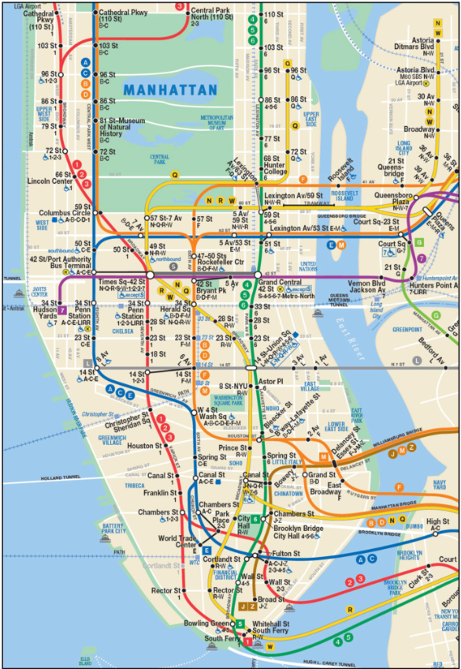
Train

 to 86th Street

to 96th Street

Bus

M86-SBS to 92nd Street and 1st Ave

M31 to 92nd Street and 1st Ave

For service status and delays information, visit mta.info for the latest updates.

